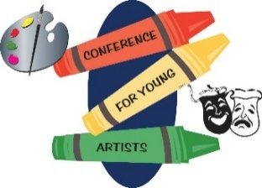**Conference for Young Artists**

October 30, 2024

Student and Adult Survey

**Name & School Name Optional:**

1. 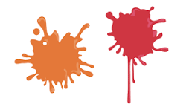**Select One**

Student  Adult

1. **What grade are you in? (Students select One)**

K  1  2  3  4  5  6  7  8

1. **Tell us how much you liked the Keynote Presentation:**

✰1 ✰2 ✰3 ✰4 ✰5

1. **What did the Keynote Presentation teach you?**
2. **Did you explore and learn something new at the conference?**

Yes  No

1. **Select the three sessions you were in:**



|  |  |  |  |  |
| --- | --- | --- | --- | --- |
| A. Create Art to Wear | B. Paper Quilting | C. Birch Tree Mixed Media | D. Beat Blast: Youth Dance & Lyric Showdown | E. Painting LOOOONG Cats |
| F. Happy Place Painting | G. Draw Your Own Cartoons | H. Let’s Paint on Wood | I. Hot Air Balloon Sculpture!! | J. Drawing Outside the Lines |
| K. E-Z Cut Block Printing | L. Dragon's Eye | M. Create a Zine & Make a Scene | N. Sculpting a Canoe | O. Expressing Your Layers |
| P. Spooky Halloween Skeletons | Q. Dance Drawing | R. Painting/Mural works 101 | S. Monster Mash Up | T. Mask Making |
| U. Clay Caricatures | V. Pottery Wheel Experience | W. THEATRE-That's R-E, not E-R! | X. Hand Letter |  |

1. **Which session was the most fun?**
2. **What made this session fun?**
3. **What did you learn?**

Flip Over

1. **Students and Adults: Would you attend the Young Artists Conference again?**

Yes  No  Maybe

1. **Adult: How has this experience influenced your student(s)?**
2. **Additional comments about the conference:**



1. **Suggestions for future topics, speakers, etc.**

**Contact: Andrea Anderson,**

**Student Enrichment Coordinator**

507-537-2257

www.swwc.org/ya

[andrea.anderson@swwc.org](mailto:andrea.anderson@swwc.org)

